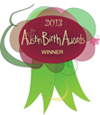
For Immediate Release Contacts:
June 8, 2013 Austin,TX Jenni Schramm, Founder
Get Babied Foundation
(512) 591-5959
Gail Gresham, President
Central Texas Healthy Mothers Healthy Babies Coalition
(512) 799-6155

Austin Birth Awards to be Announced on Oct 25th 7:00 – 9:00pm
Washington Carver Museum & Cultural Center
1165 Angelina Street, Austin, TX 78702

Thousands of votes will be cast to highlight the best in Austin’s birth professionals

In the spirit of the Austin Music Awards or the Austin Chronicle’s, Best of Austin Awards, we are happy to announce the 3rd Annual Austin Birth Awards. The 2013 Austin Birth Awards are a project of the Get Babied Foundation and the Central Texas Healthy Mothers Healthy Babies Coalition. Together, our mission is to recognize the Austin area birth professionals that are going out of their way to provide quality care for the women of Austin.
The Austin Birth Awards features a list of qualified professionals in many service areas related to birth and parenting. All finalists were nominated by those in the community who have personally experienced great service and outcomes from birth related service providers.
There are 59 categories, some of which include: Best Birth Center, Best hospital to deliver your baby, Best Lactation Consultant, Best Nutritionist, Best Childbirth Prep Class, Best Adoption Resource, Best Birth Doula, Best Infant Consignment Store, Best Prenatal Photographer… and the list goes on.
“We wanted to give Austin families a chance to speak their voice, to cast their vote for their favorite birth-related professionals- and then make that information available to all expectant families who may be seeking it,” states Ame Shillington, co-founder of the Get Babied Doula Collective.
The nomination period is open for public voting from June 1st through July 15th and consists of write in nominations for each category. Close to 2,000 nominations were submitted during this period last year. Nominations cast will be tallied and the top 4 nominees in each category are our finalists for the Birth Awards. Voting for your favorite of the top 4 nominees in each category will be from August 1st through September 15th and the winners will be announced at the Awards Gala and Reception on October 25th at the Carver Museum and Cultural Center. Last year over 6,000 votes were cast by members of the Austin community.
Event info: The Birth Awards Gala and Reception is free and open to the public. Families, finalists, birth professionals, and members of the media are encouraged to attend. The event will include cocktails and networking opportunities, a silent auction, and winners in all categories will be announced. Winners will be presented with an official certificate and a thank you gift from sponsors, along with the honor of “wearing a ribbon” on their website, indicating they were a nominee, finalist, or winner for 2013. Winners will also be listed and remain on the Austin Birth Awards website for the next year as a resource for new families with links to those providers and contributors.
For information on how to become an official sponsor for this event, please email: birthawards@getbabied.com.
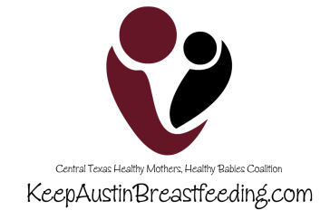
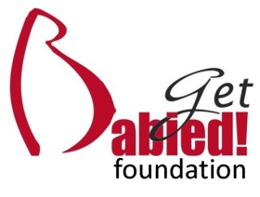
The website can be found here: www.austinbirthawards.org

